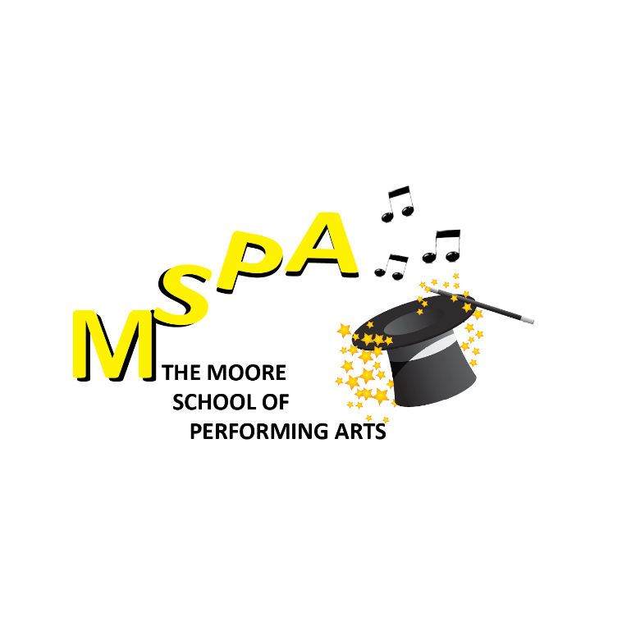
THE MOORE SCHOOL OF PERFORMING ARTS

CHILD PROTECTION POLICY

Introduction
The Moore School of Performing Arts (MSPA) aims to provide young people with the opportunity to experience all aspects of the Performing Arts in a safe and friendly environment where safety and welfare are of primary concern. We believe that all children have the right to be protected from harm at all times and in all situations, and that all children who participate can do so in an enjoyable and safe environment in which they can have fun and feel valued. To ensure that a culture of safety informs all that we do, MSPA has developed this Child Protection Policy.

The Aims of the Policy
The aim of the policy is to safeguard the personal safety of all children who take part in our weekly classes. Classes include: Musical Theatre, Creative Drama, Tap, Exam Drama, Hip-hop, Contemporary, Jazz & Technique, and Singing through actively promoting awareness, good practice, and appropriate and effective procedures.

Codes of behaviour and safety between Teachers, Assistants, and Students.
Teachers:
- Should be sensitive to the risks involved in participating in contact exercises or other activities with their pupils.
- Should never physically punish or be in any way verbally abusive to a child, or should they make comments or tell jokes of a sexual nature in the presence of a child.
- Should be sensitive to the possibility of developing favouritism or becoming overly involved or spending a great deal of time with any particular child.
- Should develop a child protection policy that raises awareness about the possibility of child abuse occurring and outline the steps to be taken if it is suspected.
- Should respect personal boundaries. Create an atmosphere of trust. Check with students about their level of comfort if doing touch exercises through drama or dance.
- Be aware of children’s limitations and of any special needs/requirements.
- Provide a safe, supervised working environment.
- Ensure children are always supervised by an Assistant if the teacher leaves the room. The Assistant should carry on the class as normal.
- Ensure children are picked up promptly after their class or workshop.
- Respect differences of ability, culture, religion, and race.
- To ensure the safety of the students, when class is over and they are going to another class, they should be walked over in a group by the teacher or the assistant in a cordially manner. No child is to walk over on his/her own unless a parent’s permission is given verbally to us.

Implementation of Behavioural Codes

- Excessive amounts of time should not be spent alone with children away from others.
- Meetings with individual children or young people should take place as openly as possible.
- If privacy is needed the door should be left open and others informed of the meeting.
- It is not good practice to take children alone on car journeys however short. If this is un-avoidable, it should be with the full knowledge and consent of the parents.
- It is not advisable to take students to their home unless you have the consent of a parent to do so.
- It is desirable for all teachers to attend a first aid course. There should be a first aid box at hand in every dance class or main office building where you teach.
- If there is a trip organised away from home, parents’ permission in writing should be received. Full details of the trip including sleeping arrangements should be agreed with and accepted by the parents or guardian. If there are mixed groups they should be accompanied by a male and female supervisor.
- When a parent is enrolling their child/children with MSPA they must register them online through our website. It is very important that all contact information and personal information
i.e., doctors contact details, written permission to take photos etc be filled in.
- Have adequate insurance for the specific number of children being supervised/taught at any given time and ensure that fire precautions are in place.
- Be aware that children have the right to be heard and taken seriously, considering their age and level of understanding. They should be consulted and involved in all matters and decisions that affect their lives. It should also be clearly understood that emotional abuse includes: verbal abuse, using bad language, persistent criticism, sarcasm, hostility or blaming, inconsistent or inappropriate expectations of a child and their capacity to understand something or to behave and control him/herself in a certain way.

BULLYING:
Bullying can be defined as repeated verbal, psychological or physical aggression conducted by an individual or group against others. It includes behaviours such as teasing, taunting, threatening, and hitting or extortion behaviour by one against a victim.
Bullying will NOT be accepted at MSPA and will be dealt with promptly and accurately by the teacher and person involved and parents will be notified immediately.

All our teachers and assistants are Garda vetted.

